

Customer Complaint

(CC)

**User Manual**

**Objective:**

This manual introduces you to the functionalities involved in tracking and approval

of Customer complaints through online, Timely closure of complaints.

**Definition:**

* CC- Customer Complaint
* Submit - This allows you to route the completed form to the next level.
* Reset - This allows you to reset the form before saving and return to complete the fresh request form.
* Cancel - This allows you to delete the form and return to fill the form again.

Index

|  |  |  |
| --- | --- | --- |
| **Sr. No.** | **Section** | **Sub - Section** |
| 1 | Log In LFG Portal | Log In Credentials |
|  |  | Forgot Password |
|  |  | Change Password |
| 2 | AMS Module | Complaint Creation |
|  |  | Compensation Creation |

**1. Getting Started:**

To access the CC Module the employee is required to use the below URL

<http://lfg.nipponpaint-groupar.com/>

**1.1 Login Credentials:**

* User ID :
* Password :

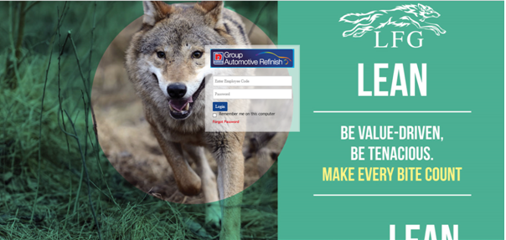

**1.2 Forgot Password:**

In case forgetting the password, Click forgot password after putting the employee code then you have received the password on mail.

**1.3 Change Password:**

Employee can change the password from the TAB “CHANGE PASSWORD” on TOP RIGHT HAND SIDE.

**1.4 HOME PAGE**

After login, the employee will be directed to the Home page of LFG Portal with CC Module:

[New LFG Screens needs to be attached]

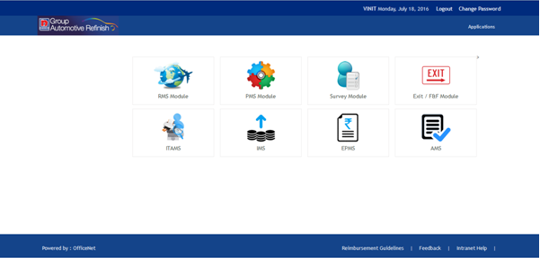

2. Once the use will click CC, a Dashboard will open and show the summary of the following:

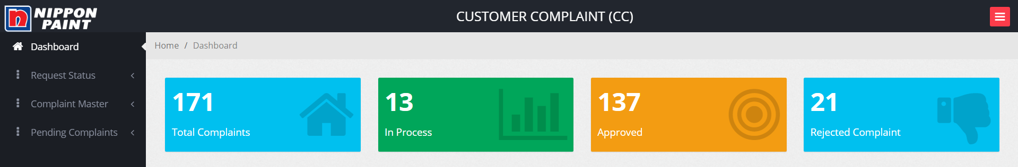

2.1 Total Complaint

2.2 In Process Complaint

2.3 Approved Complaint

2.4 Rejected Complaint

3. When User will click on Create Request:

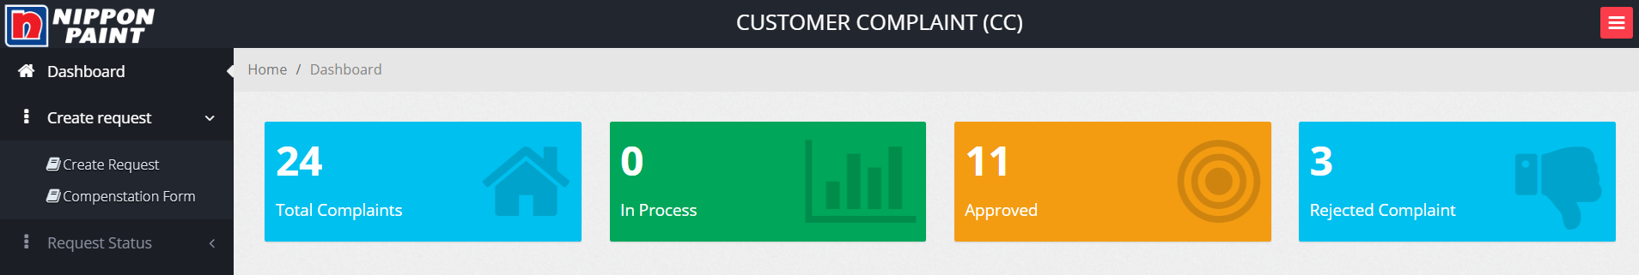

Sub Menu:

* Create Request
* Compensation Form

3.1 Once the user will click on **Create Request**, Complaint form will open:

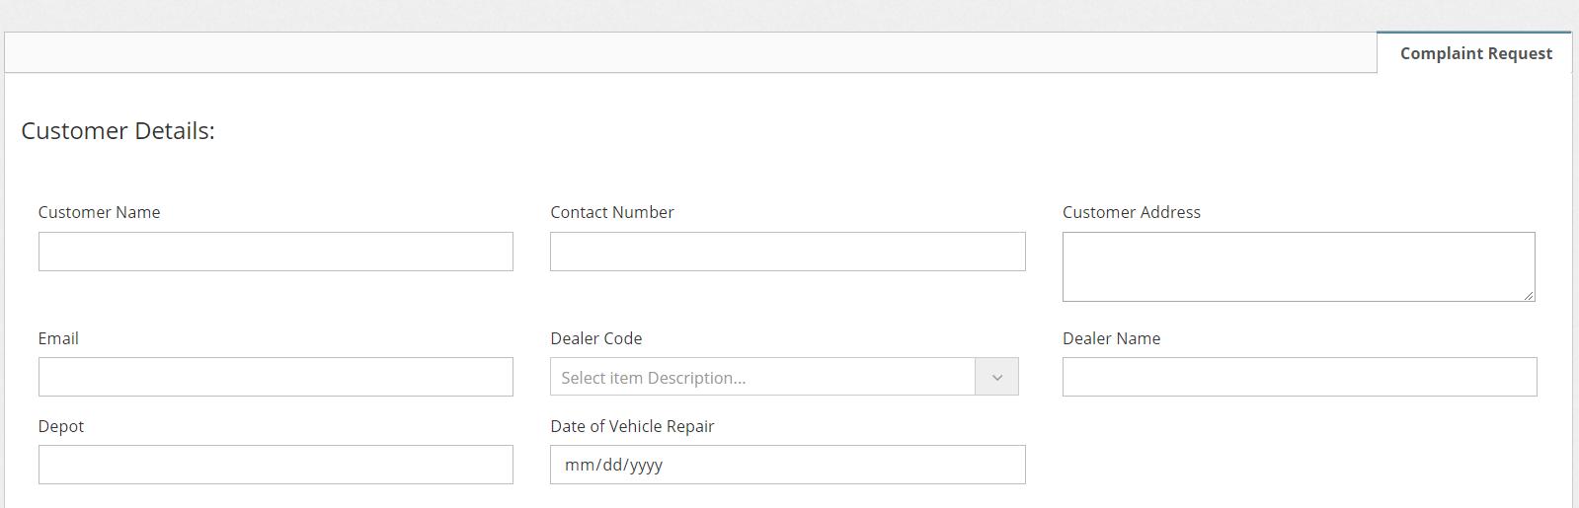

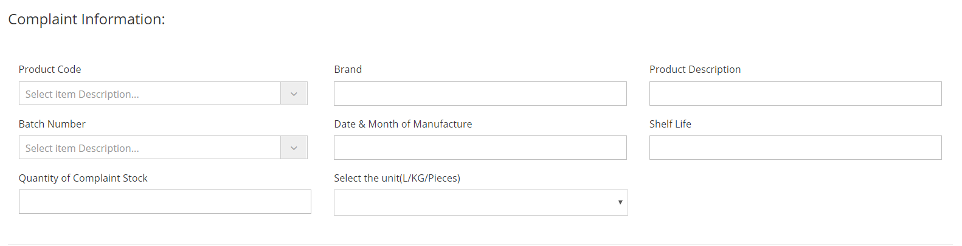

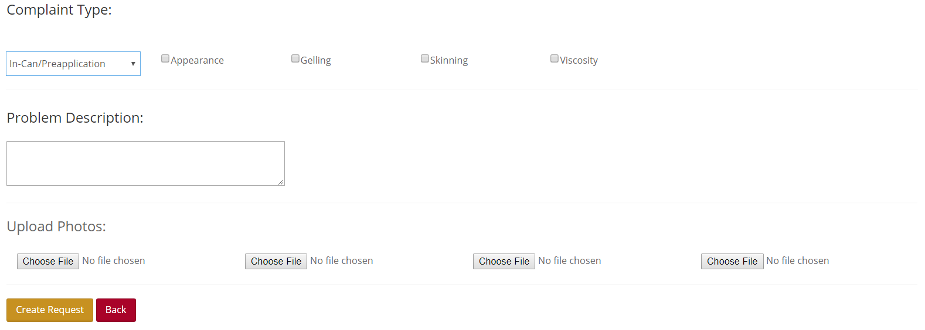

After **Submission**: Complaint would flow to **Complaint Handler** for further process:

* Customer Name : Customer Name
* Contact Number : Customer contact number
* Customer Address: Customer’s address
* Email: Customer email address for future communication
* Dealer Code : Searchable drop down where user can search for Dealer based Dealer Code/Name
* Dealer Name: This field will be auto populated based on Dealer Code
* Depot: This field will be auto populated based on Dealer Code
* Date of Vehicle Repair: Date needs to capture on which Paint was applied.
* Product Code: Searchable drop down where user can search for Product based Product Code/Name
* Brand : This field will be auto populated based on Product Code
* Product Description: This field will be auto populated based on Product Code
* Batch Number: This drop down will be auto populated based on Product Code
* Date & Month of Manufacture : This field will be auto populated based on Batch Number
* Shelf Life: This field will be auto populated based on Batch Number
* Quantity of Complaint Stock: Stock quantity for which complaint is raised
* Select the unit(L/KG/Pieces): Unit for stock
* Complaint Type: Type of complaint user is raising
  + In-Can/Reapplication
  + Packaging
  + Other Product Related
  + System Related
    - Once user selects any of these type further options open to define complaint in detail.
  + Problem Description: Free text to provide details on the problem.
  + Upload Photos: Upload photos to provide more information on the issue. User can upload up to 4 photos.

3.2. When user Clicks on **Compensation Form,** user will be able to see all the approved complaint for which compensation form can be created with status as “Pending Compensation”

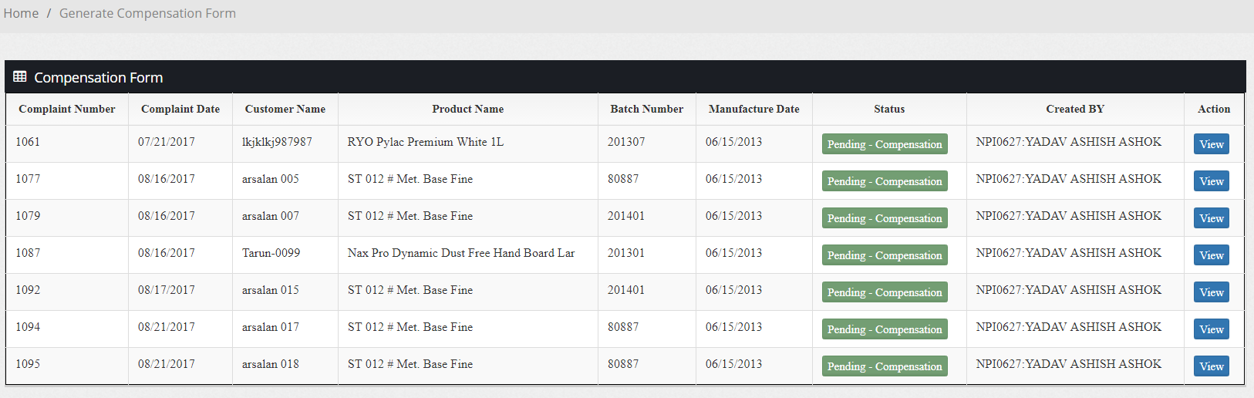

When user will click on View a pre-filled form will be displayed.

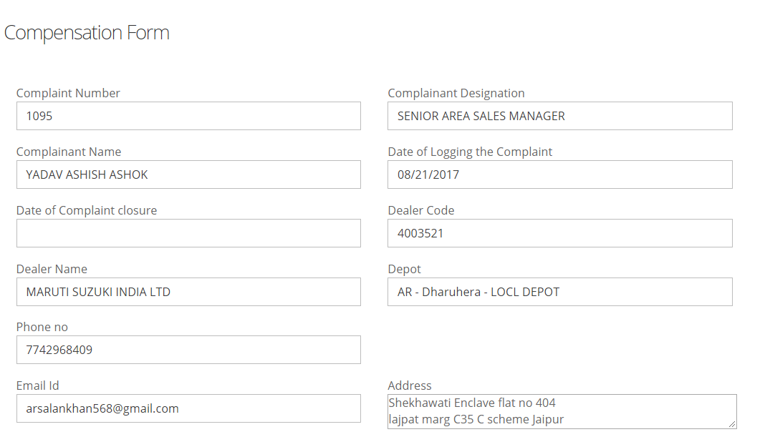

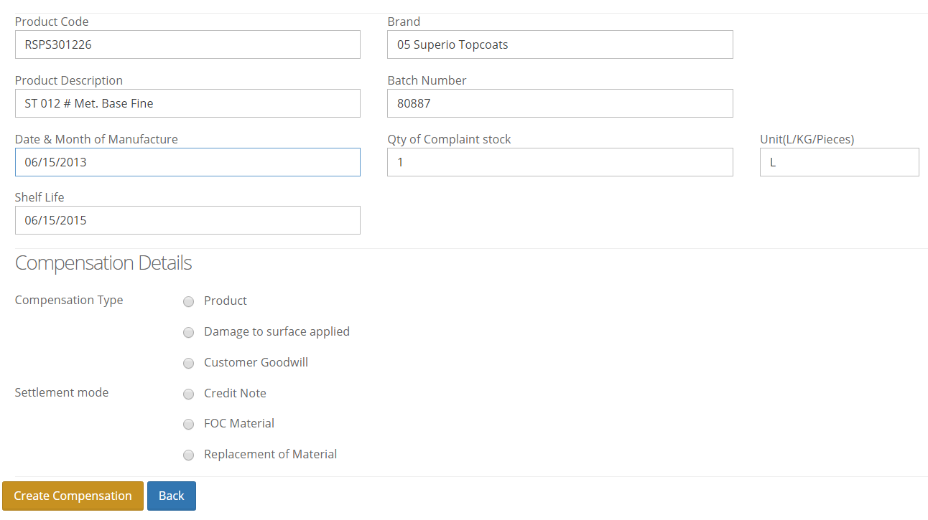

Once user clicks on “Create Compensation”, request will assigned to Business Manager for approval.